India tour 14-30 November 2018
Jaisalmer in Desert - Golden City
Day 7:- Jaisalmer day 2,
Breakfast at 7.15am and on the bus by 8.30am for a short drive to the base of the “Jaisalmer Fort”. This one was built in 1156 by a Rawal Jaisal and remains inhabited by locals in a variety of stone block accommodations interspersed with bazaars and palaces. The fort is set upon an 80 metre high hill in the centre of the city and built with the yellow sandstone to give the “golden” appearance. There were many alleyways to transverse and steep steps to climb to one of the 99 bastions for a general lookout over the city.
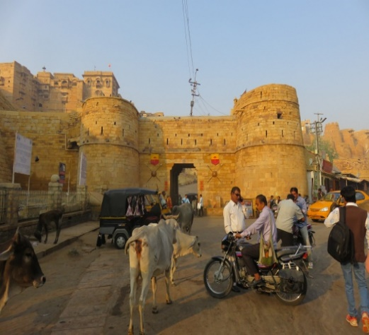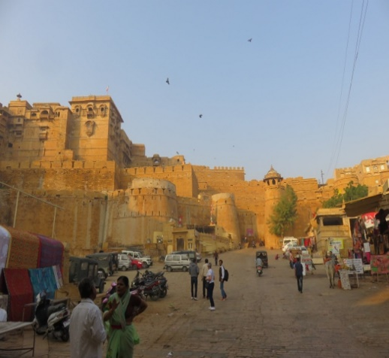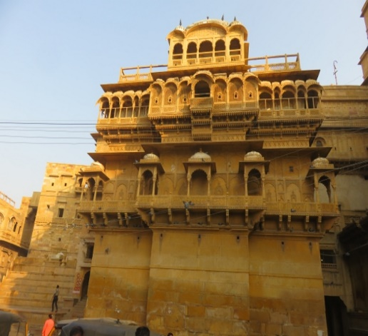
Entrance to Jaisalmer fort line up to get past camels and cows built with yellow sandstone.
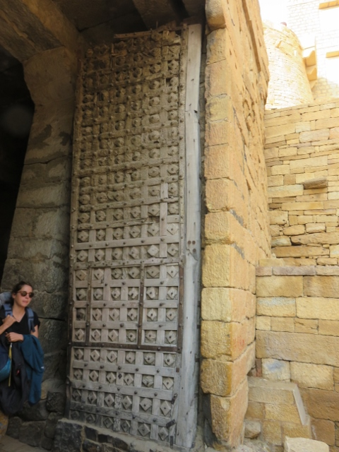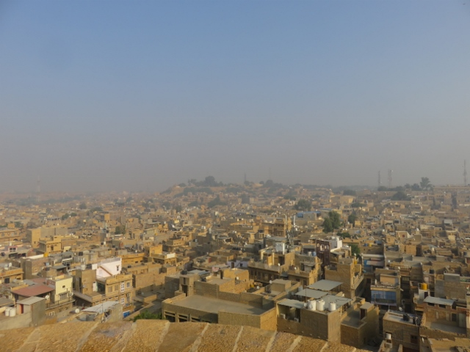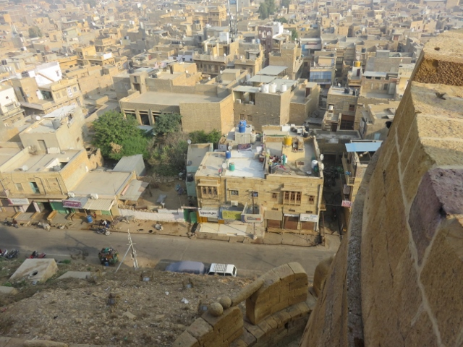
Huge gates to get inside fort view of city from a bastion called blue city with coloured roof tops.Once again the tour groups are plied by the local “flies”, read hawkers, flogging all sorts of trinkets. To them no means yes! So best to just ignore them and don’t look at what they are offering and keep walking! One of the most unusual buildings was built by 2 brothers. The building has 2 different facades, one for each brother and designed slightly different from each other in style. An inspection was arranged as it is still used by the brother’s descendants. Of course there was a “sales” room to go through before exiting the building which displayed many “Indian” style ornaments.
Back on the bus for a longer drive to what is known as a “tank” at the edge of the city. A very large lake that has been artificially made and has several temples built out on the water. This used to be the city’s water supply in earlier times.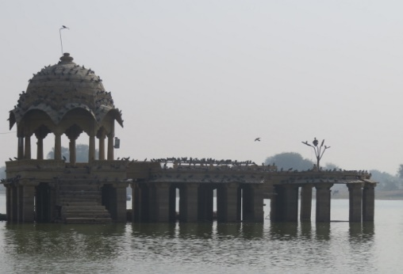 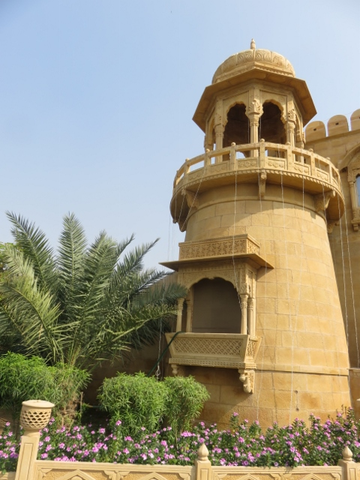 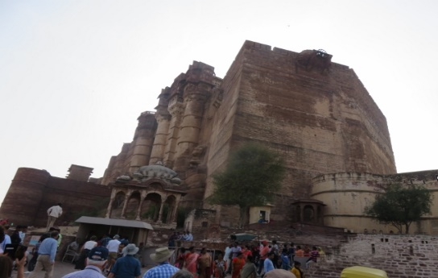
Temple in middle of “tank” lake entrance tower to “tank” perspective on height of fort.
The bus returned the group to the hotel for lunch by the swimming pool. A lovely setting and thankfully in the shade of an adjoining building. Alan’s choice mushroom soup and buttered naan bread +- a local beer. Some free time was allowed after lunch which Alan took up to wander around the extensive grounds of the hotel.
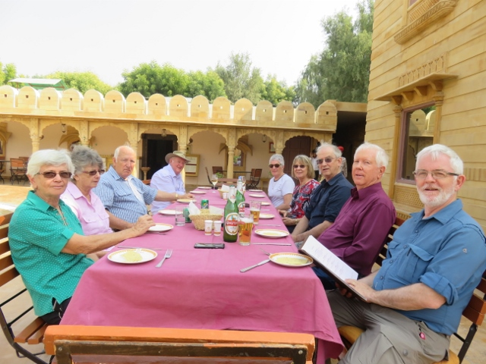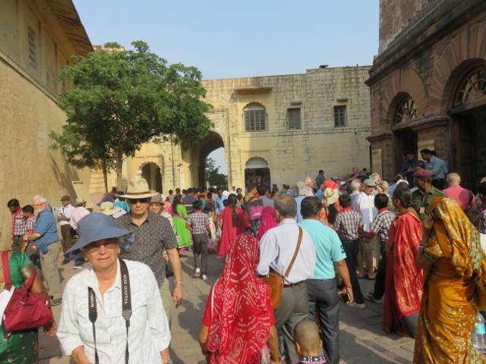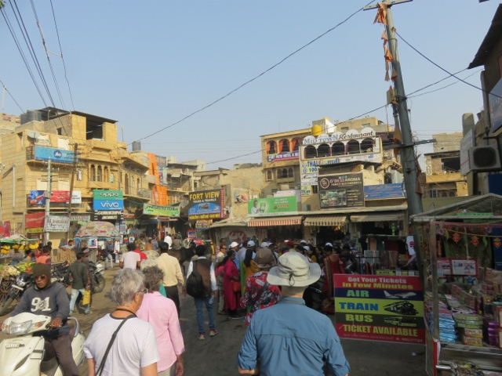
Lunch beside swimming pool colourful crowds inside fort many bazaars on exit to fort.
At 4.00pm we all left on the bus for a 45 minute drive south of the city to a place called Sam. Here a camel ride up to the sand dunes was the next excursion. Alan had a bit of a challenge in mounting the camel offered to him, being not used to lifting his leg up and over the body of the camel. Stretched some muscles around the hips a bit and then only a very small spike at the front of the saddle to hold onto as the camel rose to its feet and a “keeper” led us with the camel reins. Very scary in trying to hold on with all that swaying and occasional stumble by the camel. Alan’s camel was named Michael Jackson!
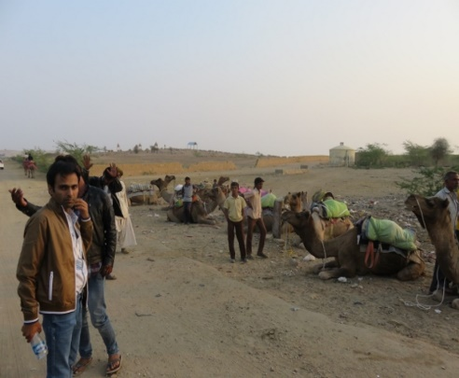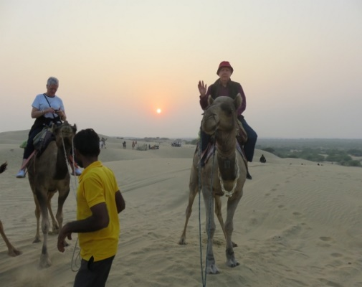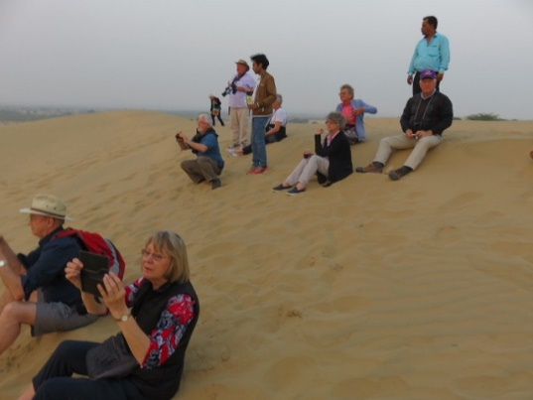
Camel assembly area at Sam Alan on Michael Jackson on right tour group relaxing at sunset on dunes.
The climb up the sand dunes took about 45 minutes an as the sun was almost setting a most spectacular sight to close off the evening. But wait there is more!!! The return camel lope down the sand hills finished at the base of the sand dunes and not the start point where we mounted the camels. The bus was waiting for us and it took us for a short drive to a walled compound in a local village arriving there in the gloom of early evening. Here we were greeted by drumming musicians and a beautifully costumed young lady who anointed each guest with a red spot on the forehead and placed a small garland over the head. This was the venue for the evening dinner.
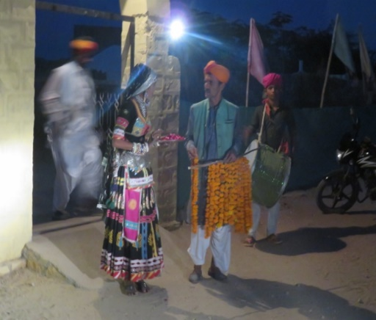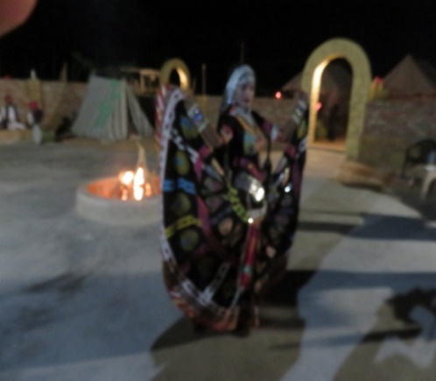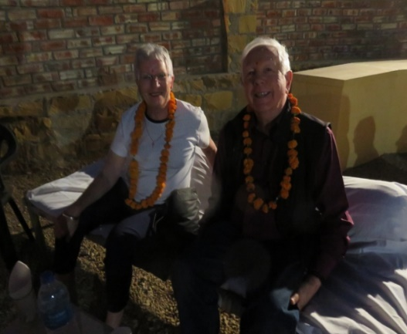
Entrance to dinner venue young dancer to entertain guests Kerry Midgley and Alan on divan for dinner.
A circle of cushioned divans was made available for the guests to lounge around in and a concrete area in the centre of the circle had a small fire place with a few logs burning to supply some additional light. The choice of meals (buffet style) was again subject to what was chilli infected or not. Not knowing what was in the meal caused some heat stress and a supply of local beer and bottled water was used to put out the fire in throat and tongue.
During the evening the musician drummers belted out their pieces and later the young lady who greeted the group at the entrance came out and performed some ritual dances (bare foot). She even managed to get the whole group up and do some twirls as well.
The event concluded at 8.45pm and the bus boarded for the return journey to the hotel which took 50 minutes arriving at 9.35pm. A most enjoyable day however somewhat challenging physically with the climbing up into the fort and mounting the camel and holding on while it climbed the sand dunes. Into bed exhausted by 10.00pm.
A few more photos for a big day:-
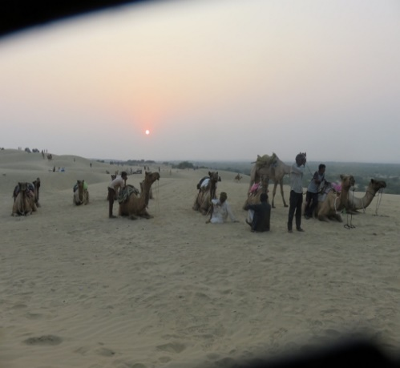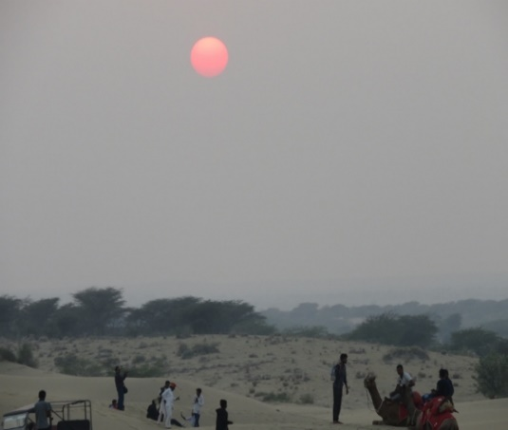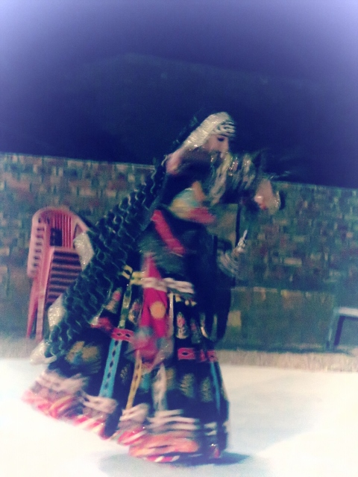
Sunset with camel party resting closer view of sunset twirling lady dancer at dinner
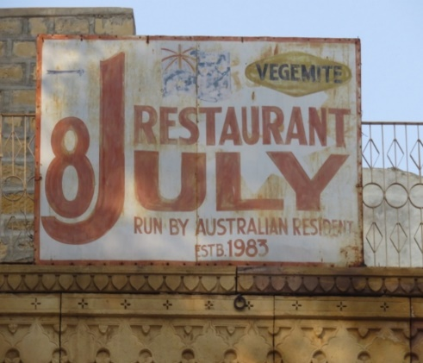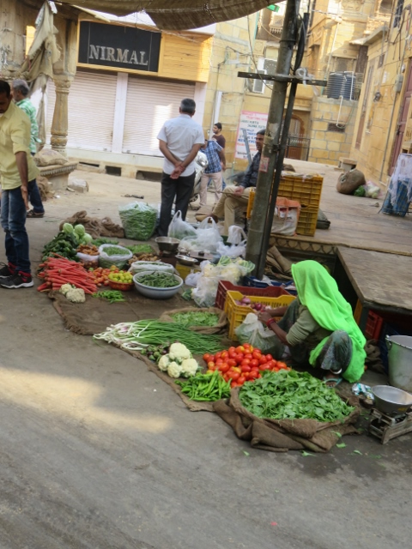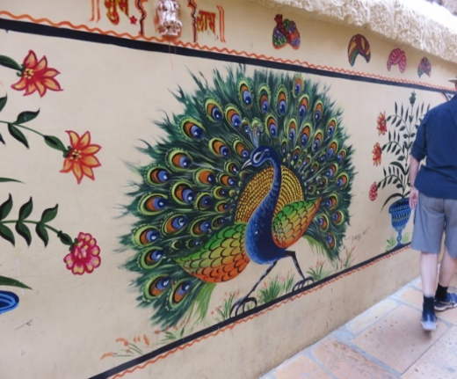
OZ vegemite sign in fort bazaar vendor lady with vegetables for sale peacock murial inside fort.
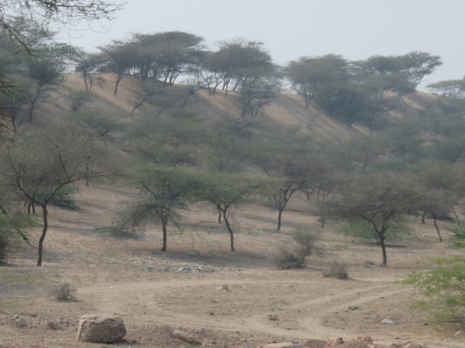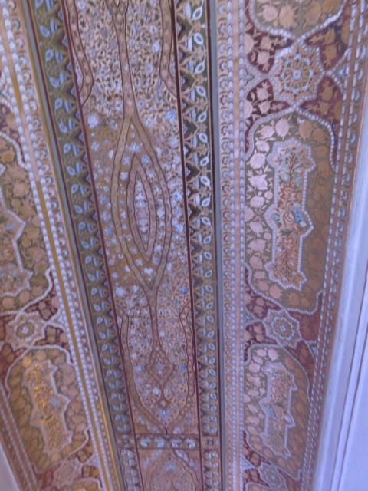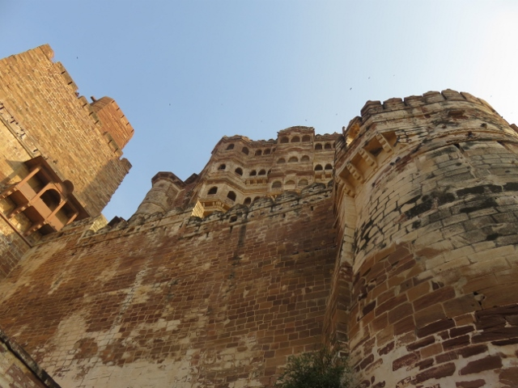
Acacia trees at base of sand dunes ceiling motif inside brothers’ house in fort another view of fort.

